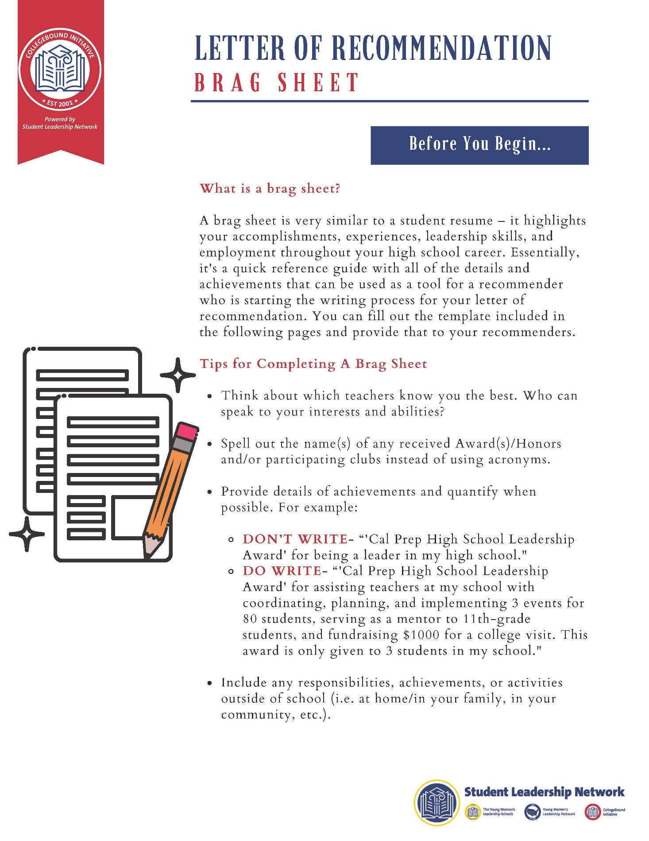

|  |  |
| --- | --- |
| **NAME:** |  |

|  |
| --- |
| **ABOUT ME** |
| List three (3) words you would use to describe yourself, and explain each with a few sentences. |
|  |
| What adjectives would your teachers use to describe you? |
|  |
| Describe an instance where an article/book/play caused you to change your way of thinking. |
|  |
| What in-school activities do you enjoy the most? Why? |
|  |
| Which high school classes excite you? |
|  |

|  |  |
| --- | --- |
| **NAME:** |  |

|  |  |  |  |  |  |  |  |
| --- | --- | --- | --- | --- | --- | --- | --- |
| What is your proudest high school academic accomplishment? | | | | | | | |
|  | | | | | | | |
| **ACADEMICS** | | | | | | | |
| Regents and AP Exam Scores (write your highest score for each exam if taken more than once) | | | | | | | |
| Algebra: |  | Second Math: |  | Living Environment: |  | Second Science: |  | |
| English: |  | Foreign Language: |  | US: |  | Global: |  | |
| **Higher-Level & College Coursework:** If you are taking/have taken any advanced/AP/honors courses, write the course name(s) here | | | | | | | |
|  | | | | | | | |
| If you are now, or have been, in the College Now program at CUNY, write the course(s) and semester(s). | | | | | | | |
|  | | | | | | | |
| What is something that people do not know about you that you would love to share? | | | | | | | |
|  | | | | | | | |

|  |  |
| --- | --- |
| **NAME:** |  |

|  |  |  |
| --- | --- | --- |
| **Extra-Curricular Activities** | | |
| Dates of involvement *(for example: Sept. 2009- Jan. 2012)* | Organization/Team  *(for example: Kennedy Campus Cheerleading Team, NYC Red Cross, etc.)* | Position/duties/honors/awards  *(for example: Team Leader, Peer Trainer, etc.)* |
|  |  |  |
|  |  |  |
|  |  |  |
|  |  |  |
|  |  |  |
|  |  |  |
|  |  |  |
|  |  |  |
|  |  |  |
|  |  |  |